Keywords:

*Author for correspondence ().
†Present address:

Abstract

The abstract should be no more than 200 words and should not contain references or unexplained abbreviations or acronyms. Your abstract should be concise and informative and should read well as a standalone piece. The general scope of the article as well as the main results and conclusions should be summarised. Please also ensure that your abstract contains all likely search terms, to assist indexers (e.g. PubMed) which scan only the title and abstract of articles. If possible, it is beneficial to have all your keywords written into the abstract.

Main Text (six pages max.)

The main text of your article should be split into informative sections such as introduction, methods, results, discussion and conclusion, but please feel free to use whichever headings and subheadings best suit your submission.

Ensure that all figures, tables and any relevant supplementary materials are mentioned in the text.

References should be written in the format indicated in the reference section of this template.

Additional Information

Information on the following should be included wherever relevant.

Acknowledgments
Please acknowledge anyone who contributed to the study but did not meet the authorship criteria.

Funding Statement
Please list the source of funding for each author.

References

1. Authors. Year. Title. Abbreviated Journal title Volume, page range. (doi)
2. Authors. Year. Title. Abbreviated Journal title Volume, page range. (doi)
3. Authors. Year. Title. Abbreviated Journal title Volume, page range. (doi)
4. Authors. Year. Title. Abbreviated Journal title Volume, page range. (doi)
5. Authors. Year. Title. Abbreviated Journal title Volume, page range. (doi)
6. Authors. Year. Title. Abbreviated Journal title Volume, page range. (doi)

Tables and Figures
Tables and Figures should be inserted in the main text. Ensure that permission has been obtained for all use of third party or previously published Figures. Table caption (9 pt, bold, Palatino-Roman) must be inserted at the top of the Table and Figure caption (9 pt, bold, Palatino-Roman) at the bottom of the figure (see example below).

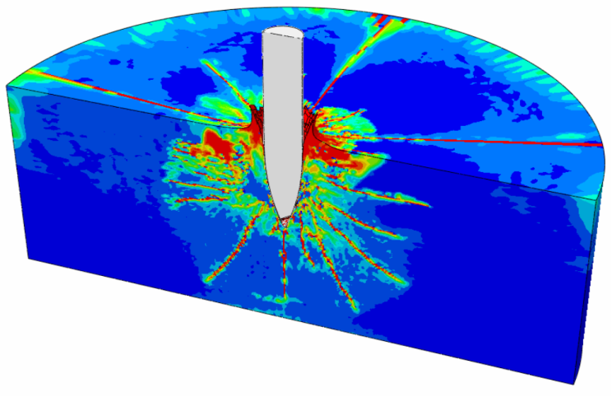
Figure 1: Impact of striker against a concrete slab.

The minimum resolution of the figure should be 150 dpi. Please ensure the good quality of the figures.

